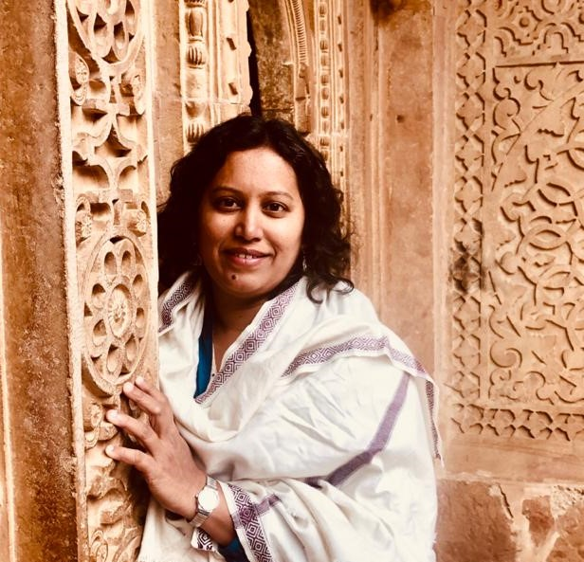 Ar. Shalaka Gotkhindikar.
Architect l Indologist
Qualification:
Bachelor of Architecture l Masters in Indology
Designation:
Visiting Faculty
Deaprtment:
FCOA
Involvement:
Visiting Faculty (Since 2017)
Teaching Profile:
- Core Faculty at IDEA (Institute of Design Environment & Architecture) Nashik- 2013-2017
- subjects: Humanities (1st year),
History of Architecture (2nd & 3rd year),
Building Construction (2nd & 3rd yr),
Building Services (2nd & 3rd yr),
Human Settlements (4th yr)
Areas of expertise:
At YCMOU (Architecture)
- External Examiner and Appointed for CAP for Subjects,
- Humanities (1st year),
- History of Architecture (2nd & 3rd year),
- Bulding Construction (2nd & 3rd yr)
E-mail:
Shalaka11sept@gmail.com l ar.shalakg@gmail.com
Brief Biography:
Shalaka Gotkhindikar offers a blend of experience of working on commercial and residential projects, in India and in Finland. Being an inquisitive and passionate professional, she makes an effort to bring in originality in design and development of the projects. A keen nature lover within her always attempt that project she works with are adaptable to environment around. With a motivation to learn, understand and adapt rising trends and technology in the architectural profession, she likes to extend her understanding in this field keeping firmly in concern with eco-friendly design and development of the projects. As an academician who is associated with various institutions, she sincerely wishes to extend the same values to her students.

Educational Background:
- S.S.C. (1995) from K.V.Kanya Vidyalaya, Panvel
- H.S.C. (1997) from S. P. College, Pune
- Bachelor of Architecture from Mumbai University, Year 2002.
- Short courses in Architecture from Tampere University of Technology, Tampere, Finland.
- Masters in Indology (Year 2014) at Tilak Maharashtra Vidyapeeth Pune, with major focus on Archaeology, Epigraphy, Numismatics, Indian Architecture and Technology, Indian Art forms and Socio-Cultural history of Ancient India.

Proffessional Background:
Independent practicing architect & interior designer since 2013
Ar. Pekka Lassila. at Tampere, Finland. Yr. 2009. l Ar. Satish V. Ahuja. at Vashi, Mumbai, India. Yr. 2003- 2007 l Ar. Ashwini Deshpande & Asso. at Vashi, Mumbai, India. Yr. 2003 l Vastukalpa at Panvel, Mumbai, India. Yr. 2001-2003

Key Compentencies:
Comprehensive Space Design (Housing, Commercial & Institutional) l Landscape Design l Indologist l Art historian l History of Architecture.

Hobbies:
- Travelling (I have traveled across India, parts of Europe and around 12,000 Kms (by road) in Scandinavia, that includes Finland, Sweden, Iceland and Norway up to Nordkapp, Norway.
- Reading.
- Trekking (I have scaled many heights in Sanhyadris & Himalayas)
- Music (listening and singing).

